**IoT based Autonomous Air Quality Analyzer and Purifier**

Anusha Aherwar  
Department of Electronics and Computer Science  
Pillai College of Engineering (PCE) [Aff. University of Mumbai]  
Panvel, Navi Mumbai  
aanusha22ecs@student.mes.ac.in

Ajay Zodge  
Department of Electronics and Computer Science  
Pillai College of Engineering (PCE) [Aff. University of Mumbai]  
Panvel, Navi Mumbai  
zajay22ecs@student.mes.ac.in

Prerna Singh  
Department of Electronics and Computer Science  
Pillai College of Engineering (PCE) [Aff. University of Mumbai]  
Panvel, Navi Mumbai  
sprerna22ecs@student.mes.ac.in

Shreeya Ghegad  
Department of Electronics and Computer Science  
Pillai College of Engineering (PCE) [Aff. University of Mumbai]  
Panvel, Navi Mumbai  
[gshreeya22ecs@student.mes.ac.in](mailto:gshreeya22ecs@student.mes.ac.in)

Swati Patil  
Department of Electronics and Computer Science  
Pillai College of Engineering (PCE) [Aff. University of Mumbai]  
Panvel, Navi Mumbai  
swatipatil@mes.ac.in

***Abstract******— This research outlines an Automatic Air Quality Analyzer and Purifier based on the Internet of Things (IoT) that monitors air quality as well as improves it in an automated way. The device consists of several gas sensors to identify the concentration of critical pollutants in air (e.g., VOCs, CO₂, and CO) and determines the air quality index (AQI) level in real-time. When AQI is determined, the device is designed to automatically move to the area with the highest AQI to facilitate purification to the theatre area. A Raspberry Pi microcontroller is used for the movement and automation of the purification methods and is controlled by an L298N motor driver with DC motors for directional movement. Real time AQI monitoring and notifications are sent to an IoT mobile-app to provide AQI update. The prototype device demonstrates a practical near cost-free portable automated solution for air purification in smart homes and environmental monitoring.***

***Keywords — Air quality monitoring, IoT, smart purifier, AQI, gas sensors, Raspberry Pi, automation, mobile app.***

# **Introduction**

Air pollution monitoring is essential for creating healthy living environments. It detects and analyzes harmful gases in the air. Unlike regular air purifiers that work statically and without awareness, smart air quality systems can sense pollution levels, make decisions, and act on them. Traditional air monitoring setups are usually fixed, expensive, and struggle to adjust to changing pollution levels in different areas. This challenge has led to the need for a compact, cost-effective, and portable option that can both analyze and purify air using real-time environmental data.

This project aims to develop an IoT-based Automatic Air Quality Analyzer and Purifier. It can detect air pollutants on its own, assess the Air Quality Index (AQI), and move toward areas with higher pollution. The system uses various gas sensors, including MQ-series sensors, to measure CO₂, CO, and volatile organic compounds (VOCs). Based on the sensor data, the system calculates the AQI and automatically moves to the most polluted area for targeted purification.

A Raspberry Pi microcontroller manages data collection and motion control. DC motors with an L298N driver allow navigation and direction changes. The purifier includes HEPA and activated carbon filters to efficiently remove dust, smoke, and toxic gases. In addition, an IoT-based mobile app gives users real-time AQI readings, and notifies them when air quality worsens.

This project shows how to successfully combine IoT sensing, embedded control, and mobility into a smart, adaptable air purification system. The proposed model is an affordable and scalable solution for homes, offices, and schools. It also lays the groundwork for future developments like cloud-based AQI mapping, AI-driven movement forecasts, and integration with smart home systems. This ultimately contributes to a healthier and more intelligent living environment.

# **Literature review**

Arpita Choudhary et al. [1] introduced the “Design and Fabrication of an IoT-based Air Purifier using HEPA Filter.” This paper presents a low-cost and effective IoT-enabled air purification system for indoor spaces. The setup uses the NodeMCU ESP8266 microcontroller, MQ135 gas sensors, a HEPA filter, and UV light for air disinfection. The purifier can monitor and purify and display air quality in real time through a mobile app/ The research shows that integrating IoT makes user interaction easier while providing reliable pollutant detection and purification feedback. This work lays the groundwork for developing portable and automated air purification systems that combine IoT, filtration, and data analysis.

Wen-Yang Wu and Yen-Chen Liu [2] presented “Autonomous Guided Robotic Systems in Regulating Indoor Environmental Quality.” This study focuses on an intelligent robotic control framework that autonomously improves indoor air quality using distributed sensors and mobile robots. The system checks air parameters from multiple wireless sensors, identifies areas that need improvement, and directs robotic purifiers using the Adaptive Monte Carlo Localization (AMCL) and Probabilistic Roadmap (PRM) algorithms. This method shows that combining robotics with environmental sensing can effectively manage and optimize indoor air conditions. The research strongly supports the movement and automation principles used in the current project, where the purifier moves on its own based on air quality levels.

K.-H. Kim et al. [3] proposed an “IoT Air Purifier with Humidification Function Capable of Removing PM1.0 Ultra-Fine Dust.” This design integrates IoT control with enhanced particulate filtration. It emphasizes combining air humidification and purification in one unit, showing how embedded systems and smart control can improve purification efficiency. This work includes multi-parameter sensing and adaptive control in IoT-based purifiers.

R. Mumtaz et al. [4] introduced “Internet of Things (IoT) Based Indoor Air Quality Sensing and Predictive Analytics — A COVID-19 Perspective.” They proposed a predictive system that can analyze indoor air quality variations using IoT sensors and data-driven analytics. The study highlights the need for real-time monitoring and automated response systems to prevent health risks from poor air quality. The integration of IoT networks and analytics closely relates to the data-driven alert system in the current project.

C. G. Kousalya et al. [5] designed an “IoT-Based Indoor Air Purifier” that combines air quality sensing with purification control through wireless communication. They used multiple sensors and Wi-Fi-enabled microcontrollers for efficient air monitoring, similar to the proposed system’s design that involves Raspberry Pi and gas sensors. It shows that real-time monitoring and actuator control can lead to effective closed-loop purification systems.

H. Dai and B. Zhao [6] explored “Reducing Airborne Infection Risk by Locating Air Cleaners at Proper Positions Indoor.” They emphasized the importance of positioning and air circulation in achieving optimal purification efficiency. The study concludes that the mobility of purifiers greatly enhances pollutant removal performance, supporting the idea of using a mobile platform in the proposed project.

The reviewed works show significant advancements in IoT-enabled air purification, air quality monitoring, and autonomous environmental control.

The combination of wireless sensing, motion control, and real-time data visualization in these studies illustrates how IoT can effectively improve environmental awareness and automation. These advancements create a solid foundation for developing smart and responsive purification systems.

Building on these contributions, the proposed IoT-based Automatic Air Quality Analyzer and Purifier introduces mobility that responds to changing air quality levels. It uses automated decision-making powered by a Raspberry Pi and provides real-time mobile app alerts for user awareness.

This combination results in a compact, smart, and adaptable system designed to ensure efficient and responsive environmental regulation.

# **SYSTEM DESIGN**

Fig. 1. System Design

The IoT-Based Automatic Air Quality Analyzer and Purifier proposed in this project continuously monitors, evaluates, and improves indoor air quality through real-time sensing, intelligent purification, and autonomous movement. The system consists of three main parts: the sensing and purification unit, the mobility control unit, and the automation and communication unit.

The sensing and purification unit uses a mix of gas and environmental sensors. It includes MQ135 for detecting CO₂, ammonia, and volatile organic compounds (VOCs); MQ7 for monitoring carbon monoxide; DHT22 for measuring temperature and humidity; and a PM2.5 dust sensor for detecting fine particles. These sensors gather data that a Raspberry Pi microcontroller processes to compute the real-time Air Quality Index (AQI).

The purification system uses HEPA and activated carbon filters to remove particles, smoke, and toxic gases. An exhaust fan placed above the filter assembly ensures consistent upward airflow, allowing for effective circulation and purification of the air.

The mobility control unit allows the purifier to move on its own using DC motors driven by an L298N motor driver module. This setup enables smooth movement in different directions within a room, letting the purifier navigate to areas with higher pollutant levels. The Raspberry Pi controls both sensor data collection and motor control, adjusting the purifier’s position based on AQI readings.

The automation and communication unit provides IoT connectivity to show live air quality data and system status on a mobile app. Users can monitor pollutant levels, receive AQI alerts. The system's combination of multiple sensors for monitoring, filtration, and IoT-based control creates a smart, portable, and flexible air purification platform, offering an effective and affordable solution for improving indoor air quality in homes and workplaces.

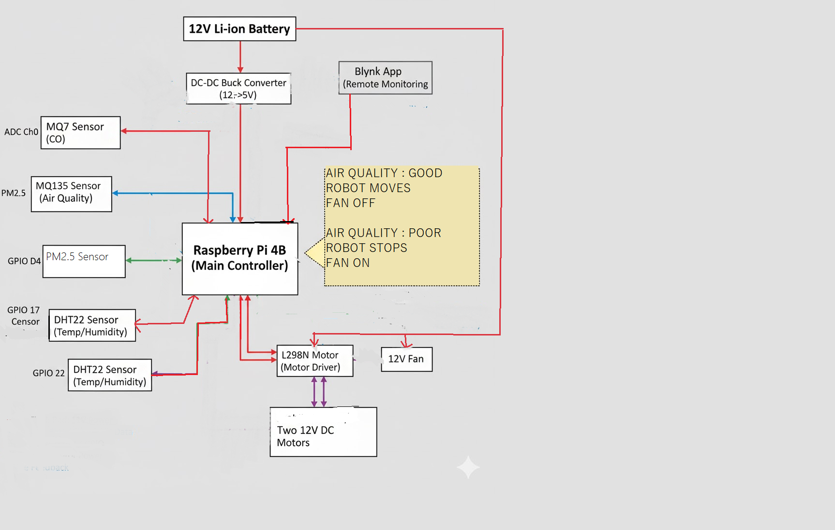

Fig. 2. Block diagram

**IV. HARDWARE IMPLEMENTATION**

The entire hardware implementation can be broken down into various main subsystems:

**4.1. Air Sensing Unit**

The air sensing unit acts as the data collection layer of the system. It brings together several sensors to track important indoor air quality parameters.

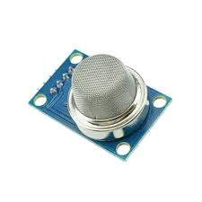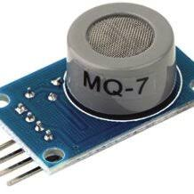

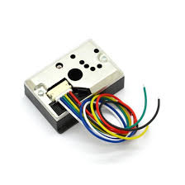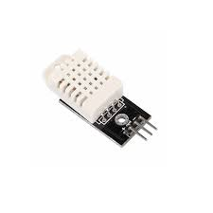

Fig. 3 Gas sensors

All analog sensor outputs connect through the ADS1115 Analog-to-Digital Converter (ADC) to provide precise digital readings before sending them to the main controller.

* Each sensor’s VCC connects to +5 V, and its ground connects to the common GND. Their analog outputs go to the ADS1115 ADC.
* The MQ-7 output goes to channel A0, and the MQ-135 output goes to channel A1. The Pi reads these values over I²C.
* The GP2Y1010F48 dust sensor has an internal IR LED and an analog output. Its VCC pin (Pin 5) connects to +5 V, and Vo (Pin 6) connects to ADS1115 channel A2. The sensor’s V-LED pin (Pin 1) connects to ground through a 150 Ω resistor to limit LED current, and its LED control pin (Pin 3) is controlled by GPIO17 on the Pi. A 220 µF decoupling capacitor is placed between the sensor’s VCC and GND pins to stabilize the supply and reduce noise.
* The DHT22 sensor provides digital readings of temperature and humidity. Its 3-pin connector is wired like this: VCC to +5 V, DATA to Pi GPIO4 (Pin 7), and GND to ground. The sensor's data line has a built-in pull-up on the 3-pin module, so you do not need an extra resistor.

**4.2. Control and Processing Unit (Raspberry Pi)**

The Raspberry Pi acts as the main processing and automation unit. It receives digital data from the sensors through the ADS1115 interface, processes this information to calculate the Air Quality Index (AQI), and makes decisions for purification and motion control. It also provides IoT connectivity to send real-time data and alerts to the connected mobile application.The control algorithms in the Raspberry Pi automate the purifier’s movement based on pollution levels and send user notifications when the AQI surpasses safe limits.

The Pi connects to a 16-bit ADS1115 ADC using I²C (GPIO2/SDA, GPIO3/SCL). The VDD pin of the ADS1115 connects to the Pi’s 3.3 V output (Pin1), and its GND connects to the common ground. This setup allows the analog inputs to measure 0–5 V signals. All sensors share a +5 V power supply from the Pi’s 5 V pins and a common ground. If a single 12 V supply were used, a DC-DC converter would reduce the voltage to +5 V for the Pi and +3.3 V for the ADC.

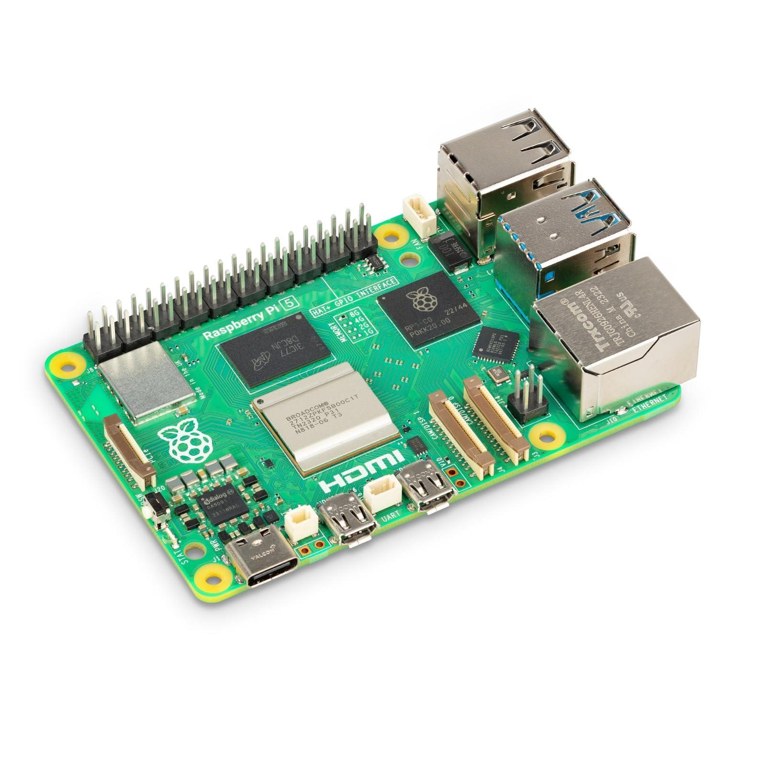

Fig. 4 Raspberry Pi Controller

**4.3. Purification System:**

The purification system filters and improves the air around it. It has a HEPA filter that removes fine dust particles and a layer of activated carbon that absorbs toxic gases and odors. A high-speed exhaust fan above the filter creates continuous upward airflow. This fan pulls in polluted air through the filtration layers and releases clean air into the environment.

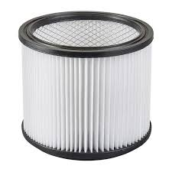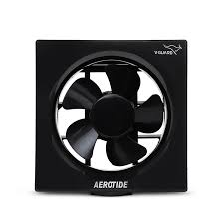

Fig. 5 HEPA filter and FAN

This setup ensures good circulation, quick purification, and steady air quality improvement.

**4.4 Mobility and Motor Control System**

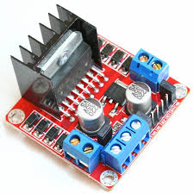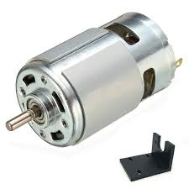

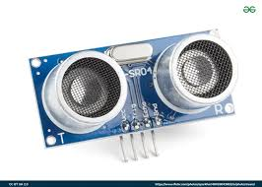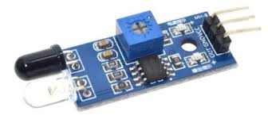

Fig.6 Obstacle Avoidance Setup

In this system, the ultrasonic sensors, motor driver (L298N), and DC motors connect to the Raspberry Pi’s GPIO pins to allow for autonomous movement and obstacle avoidance.

The front ultrasonic sensor uses GPIO pins 23 (TRIG) and 24 (ECHO). The side ultrasonic sensor uses pins 25 (TRIG) and 8 (ECHO). These sensors measure the distance to nearby obstacles by sending and receiving ultrasonic pulses. This enables the robot to stop or change direction when it detects an obstacle.

The L298N motor driver module controls two DC motors, one for the left wheel and one for the right wheel. The Raspberry Pi sends PWM and direction signals to this driver. Specifically, GPIO 13 (EN), 19 (IN1), and 26 (IN2) control the left motor. GPIO 18 (EN), 20 (IN1), and 21 (IN2) control the right motor. The EN (enable) pins receive PWM signals from the Raspberry Pi to manage motor speed. The IN1 and IN2 pairs determine each motor's rotation direction, either forward or reverse.

Each motor output terminal of the L298N driver, labeled OUT1-OUT2 for the left motor and OUT3-OUT4 for the right motor, connects to the corresponding DC motor terminals. The driver’s VCC pin connects to a 12V external power source to power the motors. The GND is shared with the Raspberry Pi ground, and the 5V OUT can optionally power the Pi’s logic circuits if needed.

**4.5. Power Supply:**

The system uses a separate +12 V DC supply as the main power source for both the air-moving fan and the motor driver. A DC-DC buck converter steps down the +12 V input to a regulated +5 V output, which powers the Raspberry Pi and the relay module. The L298N motor driver connects to the +12 V line and is used solely to drive the DC motors that enable the system’s movement. The L298N’s VCC pin receives +12 V for motor operation, its +5 V logic pin gets power from the buck converter, and all grounds (12 V, 5 V, Pi, and L298N) connect together to maintain a common reference.

A 4-channel relay module with a 5 V coil is used to switch the 12 V air-moving fan. The relay’s control side gets power from the buck converter’s +5 V output: VCC connects to +5 V, GND connects to common ground, and IN1 connects to the Raspberry Pi’s GPIO22. The fan’s +12 V supply routes through the relay’s contact terminals. COM connects to +12 V, NO connects to the fan’s positive lead, and the fan’s negative lead returns to the 12 V ground. When GPIO22 is driven LOW (active-low trigger), the relay closes the COM-NO connection, applying +12 V to the fan and turning it ON.

**V. SOFTWARE IMPLEMENTATION**

The software module manages motor control, signal capture, and automation logic for autonomous aligning and scanning.

**5.1.Controller Programming:**

The Raspberry Pi acts as the main controller and is programmed with Python in the Thonny IDE. The program continuously reads input from the MQ135, MQ7, DHT22, and PM2.5 sensors using the ADS1115 analog-to-digital converter. It processes these values to calculate the Air Quality Index (AQI) using standard thresholds. The Raspberry Pi produces PWM signals through GPIO pins to the L298N motor driver, which manages the speed and direction of the DC motors.

**5.2. Data Processing and IoT Interface:**

The processed AQI and environmental data are sent to the Blynk IoT platform via the Raspberry Pi’s built-in Wi-Fi. The Blynk mobile app offers a real-time dashboard that shows air quality details like CO₂, CO, temperature, humidity, and PM2.5 levels. With the app, users can watch air quality in real-time and get alerts when it worsens.

**5.3. Automation Algorithm:**

The automation sequence follows a feedback-based control logic, as summarized below:

1. Set up sensors and record the baseline AQI.
2. Monitor the air with MQ135, MQ7, DHT22, and PM2.5.
3. Calculate the AQI and compare it with the threshold.
4. If AQI is less than or equal to the threshold, move and scan the areas.
5. If AQI is greater than the threshold, stop, purify the air, and then resume once it returns to normal.
6. Update the Blynk dashboard with the AQI and status.

**5.4. Testing and Validation:**

The system was tested in indoor environments with artificially introduced pollutants such as smoke and exhaust gases. The sensor readings accurately reflected the rise in AQI, triggering the automation response where the fan and filter system activated while the robot halted movement.

**VI. RESULTS AND DISCUSSIONS**

The prototype of the IoT-Based Automatic Air Quality Analyzer and Purifier was successfully built and tested under controlled indoor conditions to check its performance, reliability, and efficiency. The system’s sensing, mobility, and purification modules worked well together under the control of the Raspberry Pi microcontroller, which acted as the main control unit. This setup allowed the device to detect, respond to, and improve air quality on its own with minimal delay.

During testing, the gas sensors (MQ135 and MQ7) showed high sensitivity in detecting changes in air composition when exposed to cigarette smoke, exhaust gases, and other pollutants. These sensors effectively measured variations in CO₂, CO, and volatile organic compounds (VOCs), proving they were suitable for real-time indoor air monitoring. The DHT22 and PM2.5 sensors provided consistent and accurate readings of temperature, humidity, and fine particulate matter levels, which were crucial for calculating the Air Quality Index (AQI). All analog sensor outputs were turned into precise digital readings using the ADS1115 analog-to-digital converter, ensuring better signal quality, less noise, and high data accuracy throughout the process.

The mobility control subsystem, which included dual DC motors powered by the L298N motor driver, showed smooth movement and stable responses in both automatic and scanning modes. The system could navigate to different indoor areas and effectively find spots with higher pollution levels. When it detected an AQI value above a set threshold, the built-in control logic automatically stopped movement and turned on the purification system. The HEPA and activated carbon filters, supported by the high-speed exhaust fan, created strong and even airflow through the filtration chamber, reducing particulate and gaseous pollutants within minutes of starting. AQI readings after purification showed a clear improvement in air quality, confirming the effectiveness of the combined filtration and automation system.

The IoT functionality, created through the Blynk platform, provided stable wireless connectivity and real-time data transmission to the mobile application. The app interface displayed live AQI trends, individual sensor readings, temperature, humidity, and system status. Users received instant alert notifications when AQI values exceeded safe limits, giving immediate feedback and confirming the reliability of the automation and IoT communication components.

Overall, the prototype performed reliably and consistently across multiple test trials. The integrated system demonstrated its ability to sense environmental changes in real time, respond on its own, and purify indoor air effectively. Its compact design, low energy use, and responsive performance make it a promising solution for smart indoor air management.

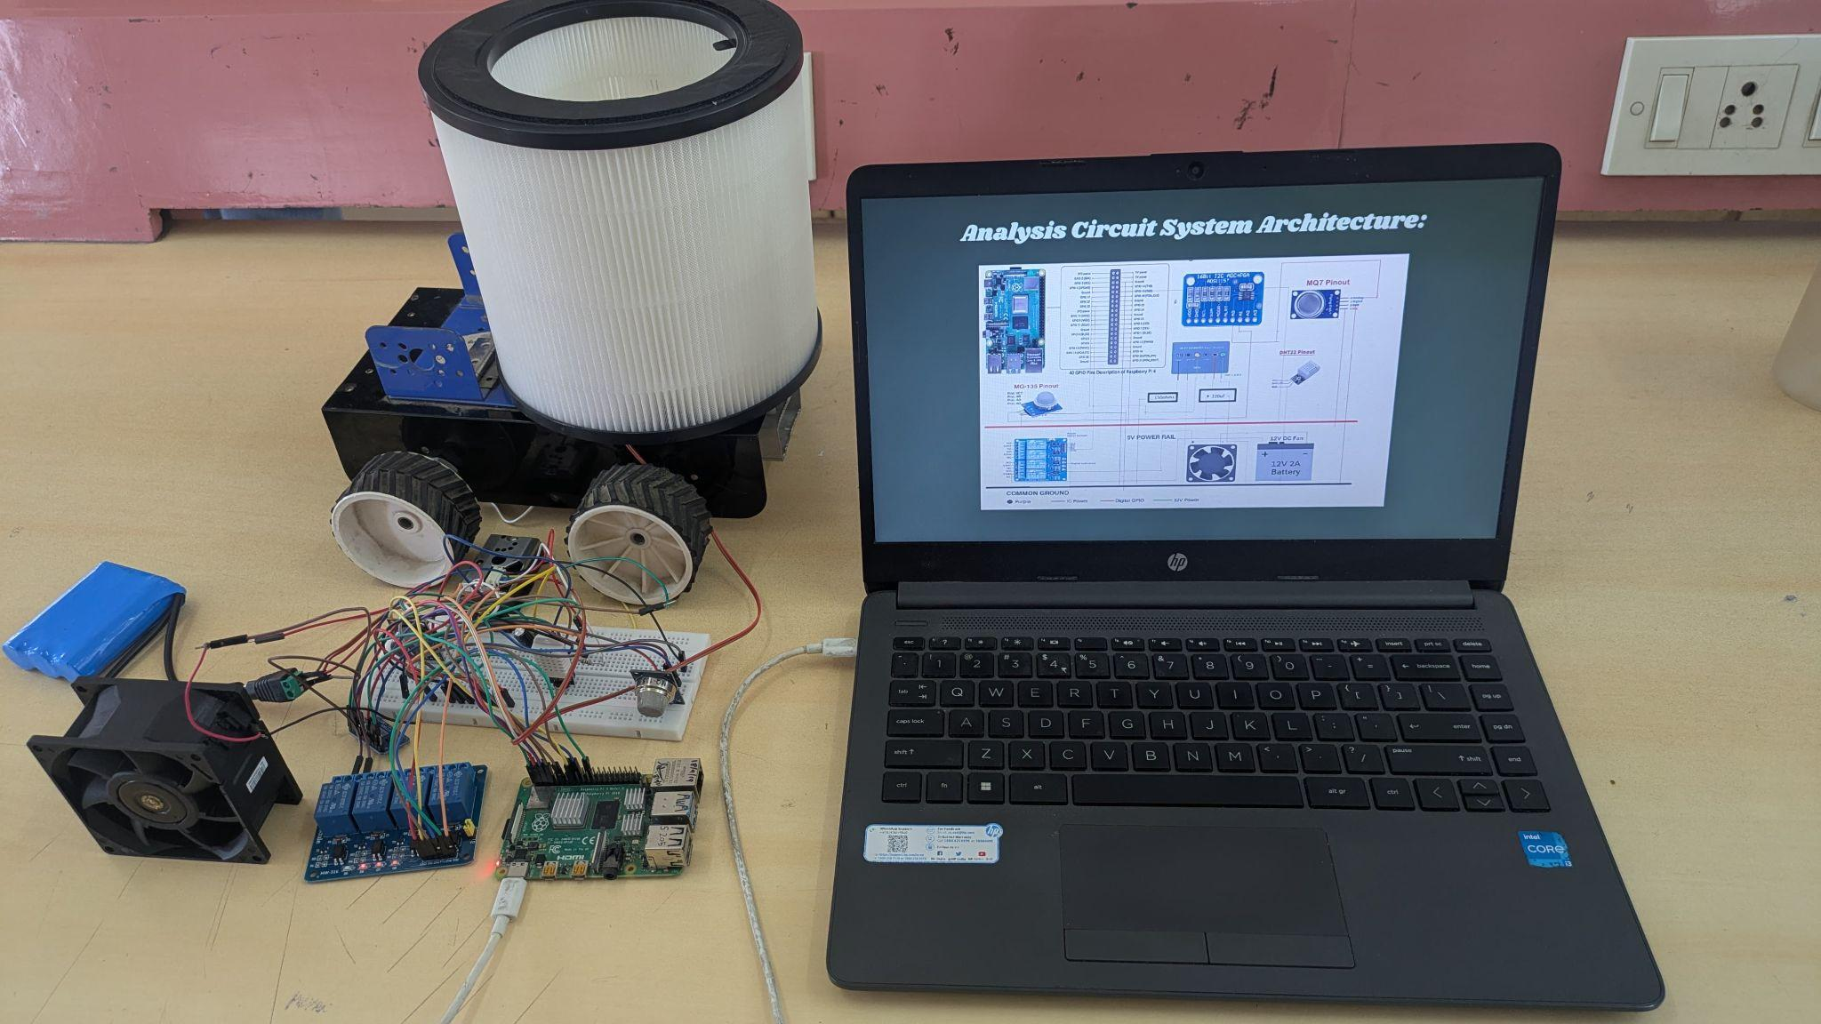

Fig.7 System Connections

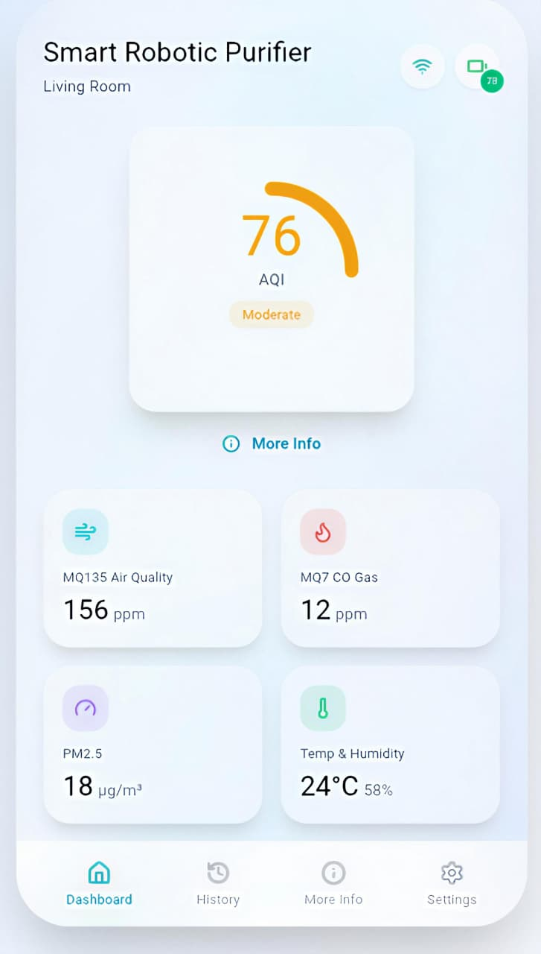 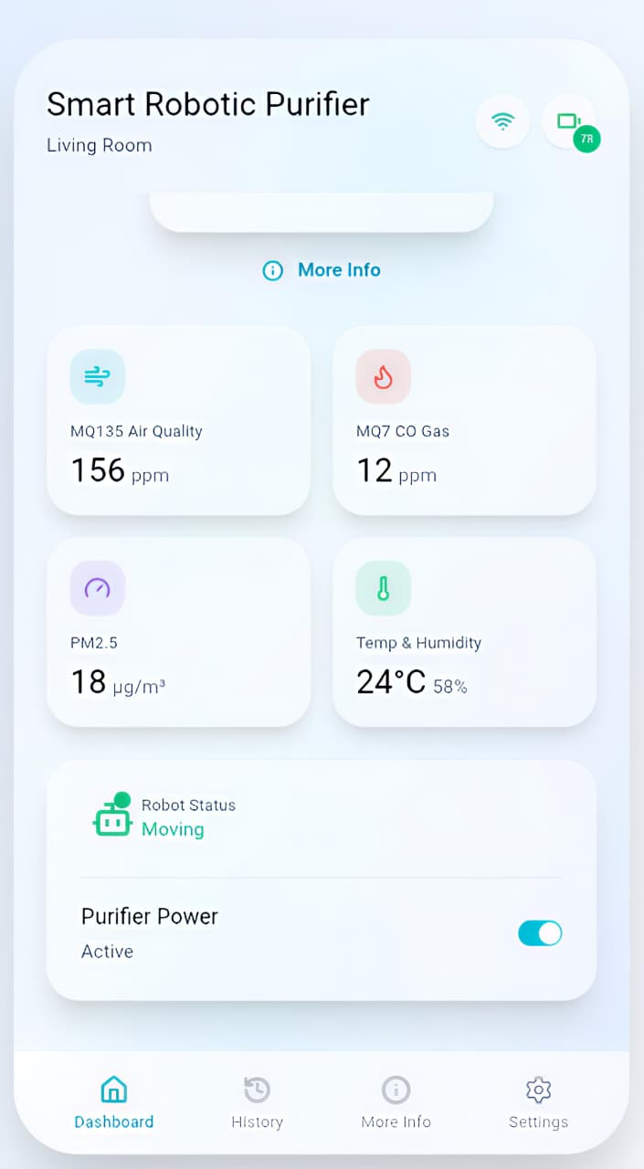

Fig. 8 AQI Readings

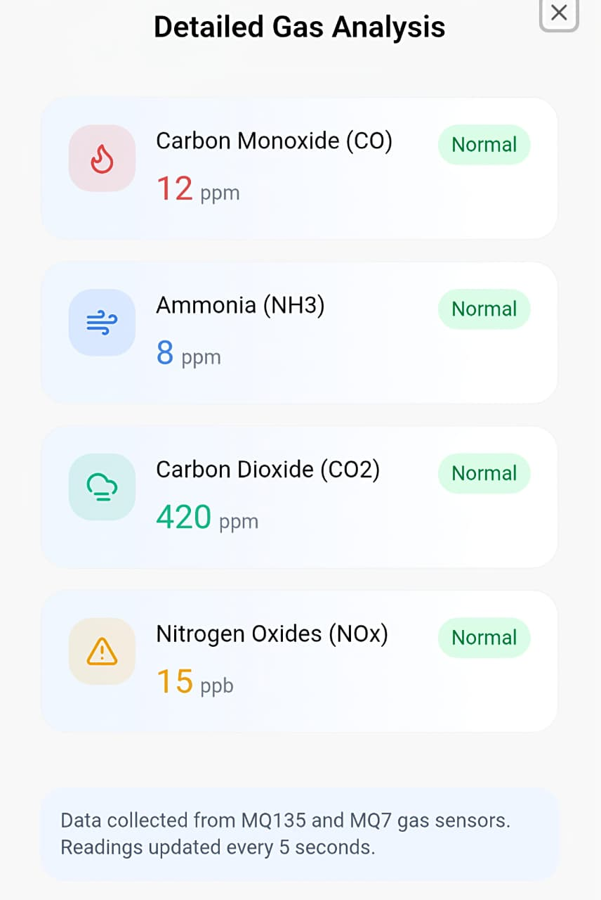

Fig. 9 Detailed Analysis of GAS

**VII. CONCLUSION AND FUTURE SCOPE**

The IoT-Based Automatic Air Quality Analyzer and Purifier efficiently combines sensing, purification, automation, and IoT communication into a compact and smart system. The Raspberry Pi microcontroller plays a key role in coordinating various subsystems, including sensor data collection, data processing, motor control, and wireless communication. This setup allows the purifier to operate on its own. It detects air pollution levels, makes real-time decisions, and takes necessary actions without needing human help.

The sensors included—MQ135, MQ7, DHT22, and PM2.5—provided accurate and reliable measurements of important environmental factors such as carbon dioxide (CO₂), carbon monoxide (CO), volatile organic compounds (VOCs), temperature, humidity, and fine particulate matter. The Raspberry Pi processed the data from these sensors to calculate the Air Quality Index (AQI), which served as the main measure of air purity. If the AQI went above a set limit, the system automatically stopped moving, turned on the purification unit, and only resumed movement after the air quality returned to safe levels.

The purification system includes a HEPA filter and an activated carbon filter. This setup effectively removes dust, smoke, and toxic gases from the air. The HEPA filter captures tiny particles like PM2.5 and PM10, while the activated carbon filter absorbs harmful chemical fumes and odors. This combination greatly reduces airborne pollutants, resulting in noticeably cleaner and healthier air in a short time.

In addition, the IoT-enabled Blynk mobile app gives users an easy and interactive way to monitor air quality in real time. Through this app, users can see live sensor data, AQI levels, and system status, along with instant notifications during times when air quality worsens.

Overall, the system offers a cost-effective, energy-efficient, and portable air purification solution that combines smart sensing, automation, and IoT technology. It is ideal for homes, offices, classrooms, and healthcare settings, providing an intelligent way to keep indoor air safe and healthy.

**Future Scope:**

Future improvements can focus on adding UVC light disinfection to the purifier. UVC radiation can effectively destroy airborne bacteria and viruses, improving the system’s ability to sterilize beyond just removing particles and gas.

Additionally, the mobile application can be expanded to include manual control features. This will let users operate the purifier directly. For instance, they could adjust the fan speed, set the purification duration, or manually guide the purifier to specific areas.

The IoT interface can be extended to support remote access from anywhere in the world. This will enable users to monitor and control the purifier through an internet-connected mobile or web platform. They will be able to turn the purifier on or off, change modes, or check air quality even when they are away from home.

##### **REFERENCES**

1. A. Choudhary, L. Saini, A. Ahmad, H. Banerjee, and F. Gazi, “Design and Fabrication of an IoT-based Air Purifier using HEPA Filter,” *Proc. 11th Int. Conf. on Internet of Everything, Microwave Engineering, Communication and Networks (IEMECON)*, 2023, pp. 1–7.
2. W.-Y. Wu and Y.-C. Liu, “Autonomous Guided Robotic Systems in Regulating Indoor Environmental Quality,” *Proc. IEEE/ASME Int. Conf. on Advanced Intelligent Mechatronics (AIM)*, Auckland, New Zealand, 2018, pp. 188–193.
3. K.-H. Kim, J.-O. Kim, Y.-H. Lee, and Y.-H. Kim, “IoT Air Purifier with Humidification Function Capable of Removing PM1.0 Ultra-Fine Dust,” *J. of KIIT*, vol. 19, no. 6, pp. 49–55, 2021.
4. R. Mumtaz, S. M. H. Zaidi, M. Z. Shakir, U. Shafi, M. M. Malik, A. Haque, S. Mumtaz, and S. A. R. Zaidi, “Internet of Things (IoT) Based Indoor Air Quality Sensing and Predictive Analytics — A COVID-19 Perspective,” *Electronics*, vol. 10, no. 2, p. 184, 2021.
5. C. G. Kousalya, U. M. Boppana, R. Kondapalli, M. T. Ahammed, C. G. S. Gallardo, P. Balaji, and M. Afroj, “Design of IoT-Based Indoor Air Purifier,” *Proc. 3rd Int. Conf. on Intelligent Computing Instrumentation and Control Technologies (ICICICT)*, 2022, pp. 1534–1539.
6. H. Dai and B. Zhao, “Reducing Airborne Infection Risk of COVID-19 by Locating Air Cleaners at Proper Positions Indoor: Analysis with a Simple Model,” *Building and Environment*, vol. 213, p. 108864, 2022.